clinicalresponse Package Pseudo Code

Purpose:

The aim of this package is for all clinics caring for patients with epilepsy to be able to calculate various seizure and med response values using collected data.

List of R packages that clinicalresponse package uses:

1. RMySQL,
2. methods,
3. ggplot2,
4. digest,
5. grid,
6. gtable,
7. MASS,
8. plyr,
9. reshape2,
10. scales,
11. stats,
12. dplyr,
13. assertthat,
14. utils,
15. R6,
16. tibble,
17. magrittr,
18. lazyeval,
19. DBI,
20. readxl,
21. tibble,
22. gtable,
23. scales,
24. Rcpp,
25. munsell,
26. colorspace,
27. plyr,
28. lubridate,
29. stringr,
30. stringi,
31. labeling
32. lubridate interval,
33. lubridate dyears,
34. dplyr tbl_df
35. rJava
36. xlsx
37. openxlsx

List of Data Source Sheets that clinicalresponse uses:

1. FILA_SEIZURE_DATA_SOURCE.xlsx
2. FILA_SEIZURE_RANKING_SOURCE.xlsx
3. FILA_MED_DATA_SOURCE.xlx
4. MED_RANKING_SOURCE.xlsx
5. DEMOGRAPHIC_SOURCE.xlsx
6. FILA_ANTHROPOMETRIC_CLINICAL.xlsx
7. FILA_MED_DATA_CLINICAL.xlsx
8. FILA_SEIZURE_DATA_CLINICAL.xlsx
9. CLINIC_VISIT_SOURCE.xlsx
10. KGID_MRNUMBER_LINK_SOURCE.xlsx

Function Explanations

1. Calculate_seizure_load
   1. Purpose: End result of this script is to obtain a seizure load per seizure for every single day.
   2. This script has 5 other functions needed to achieve result. Those functions are
      1. calculate_ranks.R
         1. Purpose: Orders seizure_ranking_source in increasing numerical order based on ranking value
      2. makelowercase.R
         1. Purpose: makes all data lower case
      3. seizure_sum.R
         1. Purpose: Assigns each observed value in seizure_data_source a ranking value based on the ranking in seizure_ranking_source
         2. This function has 2 other functions needed to achieve result
            1. Rankiwithvalues.R

Purpose: Ranking of any variable that assigns ranking values based on discrete values (i.e. variable, type, severity)

* + - * 1. Rankwithranges.R

Purpose: Ranking of any variable that assigns ranking values based on ranges (i.e. length, cluster)

* + 1. missing_sums.R
       1. Purpose: Obtains values for days with missing data using defined algorithm
       2. Process
          1. Baseline data and therapy data are calculated separately. Each section of consecutive days requiring impute method is calculated separately
          2. 1) Determine number of consecutive days requiring impute method
          3. 2) Divide the number of consecutive days requiring impute method by 2

1st half of consecutive days requiring impute method

Impute 1st half using Seizure Load per seizure from dates (immediately before the consecutive dates that require impute method) that are records and recall. The oldest date from records and recall becomes the first date in the 1st half of consecutive days requiring impute method. Seizure Load from dates that are records and recall are repeated until all dates requiring impute method are filled in.

2nd half of consecutive days requiring impute method

Impute 2nd half using Seizure Load per seizure from dates (immediately after the consecutive dates that require impute method) that are records and recall. The newest date from records and recall becomes the last date in the 2nd half of consecutive days requiring impute method. Seizure Load from dates that are records and recall are repeated until all dates requiring impute method are filled in.

* + 1. Calculate_seizure_response
       1. Purpose: End result of this script graphs seizure score per day and seizure score per 30 days.
       2. This script has 1 function needed to achieve result. That functions is
          1. Seizure_calculate.R

Purpose: Calculates change in seizure load from baseline to a time period on therapy.

* + 1. Outputs are
       1. FILA_SEIZURE_LOAD.xlsx
       2. FILA_SEIZURE_DATA_CLINICAL.xlsx
       3. FILA_SEIZURE_DAILY_GRAPH.png
       4. FILA_SEIZURE_SCORE_GRAPH.png

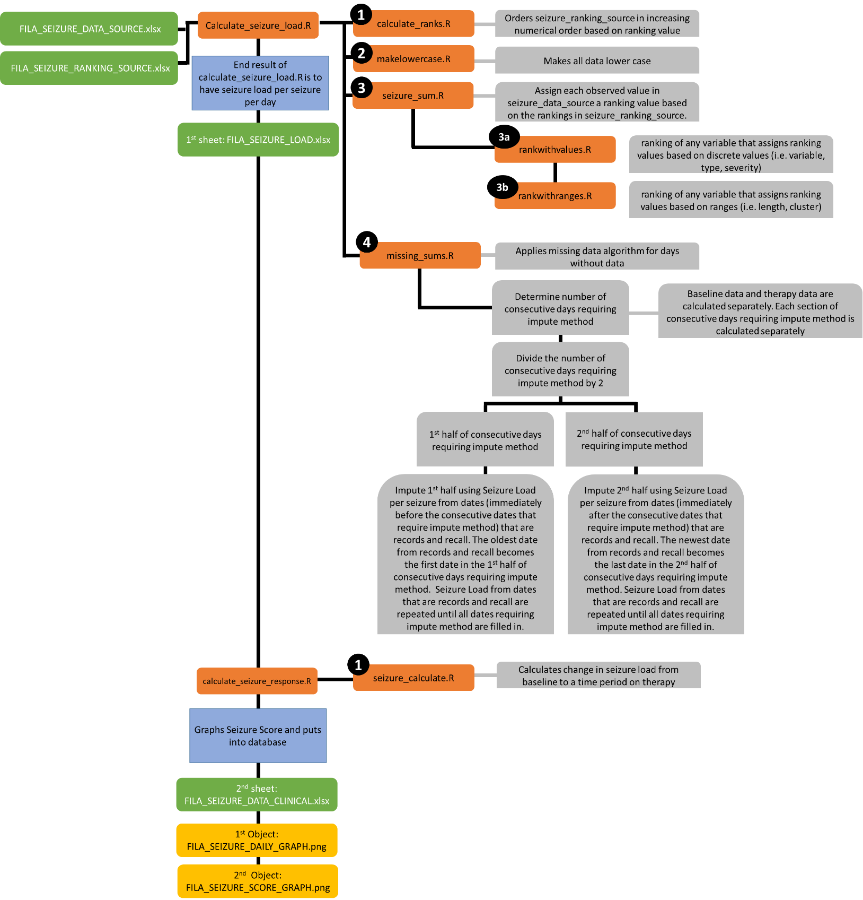

Figure 1. Algorithm of Seizure Score scripts

1. Calculate_med_load
   1. Purpose: End result of this script is to obtain a med load per med for every single day.
   2. This script has 1 other functions needed to achieve result. That functions is
      1. Calculate_med_response
         1. Purpose: End result of this script graphs med score per day and med score per 30 days.
         2. This script has 1 other functions needed to achieve result. That functions is
            1. Med_calculate

Purpose: Calculates change in med load from baseline to a time period on therapy

* + 1. Outputs are
       1. FILA_MED_LOAD.xlsx
       2. FILA_MED_DATA_CLINICAL.xlsx
       3. FILA_MED_DAILY_GRAPH.png
       4. FILA_MED_SCORE_GRAPH.png
       5. FILA_MED_LOAD_GRAPH.png

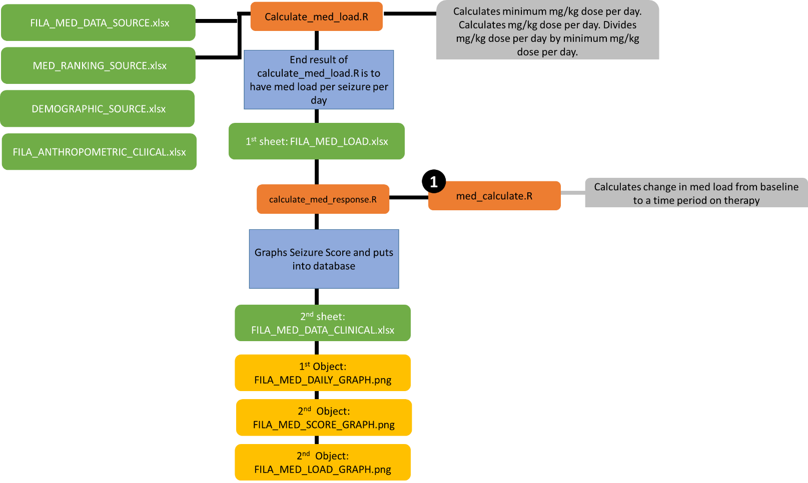

1. Calculate_outcome.R
   1. Purpose: Averages Seizure Score and Med Score to obtain outcome
      1. To create bar graphs
         1. 1) Determine clinic time periods from clinic visit source sheet
         2. Seizure Score
            1. Determine percent of days Seizure Response per day is in one of the following category in each clinic time period

0-10%

10-80%

>80%

* + - 1. Med Score
         1. Determine percent of days Med Response per day is in one of the following category in each clinic time period

0-10%

10-80%

>80%

* + - 1. Outcome Score
         1. Determine percent of days Outcome per day is in one of the following category in each clinic time period

0-10%

10-80%

>80%

* + 1. Outputs
       1. FILA_OUTCOME_DATA_CLINICAL.xlsx
       2. FILA_SEIZURE_BAR_GRAPH.png
       3. FILA_MED_BAR_GRAPH.png
       4. FILA_OUTCOME_BAR_GRAPH.png
       5. FILA_OUTCOME_BAR_TABLE.xlsx

